Question 2:Design an 3 hall sensor based outer runner Rotor Brushless DC (BLDC) Motor with proper analytical modeling and FEA simulation, considering the following specifications:

Specifications:

Motor Power: 300W

Voltage: 24V

Efficiency: 95%

Power Factor: 0.95

Base RPM: 3000

Motor Outer Diameter: <50mm

Motor Stack Length:<35mm

|  |  |
| --- | --- |
| General Data | Value |
| Rated Output Power (kW) | 0.3 |
| Rated Voltage (V) | 24 |
| Number of Poles | 8 |
| Given Rated Speed (rpm) | 3000 |
| Frictional Loss (W) | 2 |
| Windage Loss (W) | 2 |
| Rotor Position | Outer |
| Type of Load | Constant Power |
| Type of Circuit | Y3 |
| Lead Angle of Trigger in Elec. Degrees | 0 |
| Trigger Pulse Width in Elec. Degrees | 120 |
| One-Transistor Voltage Drop (V) | 0.1 |
| One-Diode Voltage Drop (V) | 0.7 |
| Operating Temperature (C) | 60 |

|  |  |
| --- | --- |
| Full Load Data | Value |
| Average Input Current (A) | 14.6938 |
| Root-Mean-Square Armature Current (A) | 12.675 |
| Armature Thermal Load (A^2/mm^3) | 467.782 |
| Specific Electric Loading (A/mm) | 21.3596 |
| Armature Current Density (A/mm^2) | 21.9004 |
| Frictional and Windage Loss (W) | 6.46288 |
| Iron-Core Loss (W) | 0.000289665 |
| Armature Copper Loss (W) | 42.456 |
| Transistor Loss (W) | 3.02055 |
| Diode Loss (W) | 0.575113 |
| Total Loss (W) | 52.5148 |
| Output Power (W) | 300.135 |
| Input Power (W) | 352.65 |
| Efficiency (%) | 85.1085 |
| Rated Speed (rpm) | 3764.89 |
| Rated Torque (N.m) | 0.761266 |
| Locked-Rotor Torque (N.m) | 6.61458 |
| Locked-Rotor Current (A) | 134.939 |

|  |  |
| --- | --- |
| Stator Data | Value |
| Number of Stator Slots | 12 |
| Outer Diameter of Stator (mm) | 34 |
| Inner Diameter of Stator (mm) | 18 |
| Type of Stator Slot | 4 |
| Stator Slot hs0 (mm) | 0.5 |
| Stator Slot hs1 (mm) | 0 |
| Stator Slot hs2 (mm) | 4.36604 |
| Stator Slot bs0 (mm) | 2.5 |
| Stator Slot bs1 (mm) | 4.67951 |
| Stator Slot bs2 (mm) | 2.33975 |
| Stator Slot rs (mm) | 0 |
| Top Tooth Width (mm) | 3.99715 |
| Bottom Tooth Width (mm) | 3.99715 |
| Skew Width (Number of Slots) | 0 |
| Length of Stator Core (mm) | 35 |
| Stacking Factor of Stator Core | 0.95 |
| Type of Steel | steel_1010 |
| Slot Insulation Thickness (mm) | 0 |
| Layer Insulation Thickness (mm) | 0 |
| End Length Adjustment (mm) | 0 |
| Number of Parallel Branches | 2 |
| Number of Conductors per Slot | 30 |
| Type of Coils | 21 |
| Average Coil Pitch | 1 |
| Number of Wires per Conductor | 1 |
| Wire Diameter (mm) | 0.607 |
| Wire Wrap Thickness (mm) | 0 |
| Slot Area (mm^2) | 16.5732 |
| Net Slot Area (mm^2) | 15.3232 |
| Limited Slot Fill Factor (%) | 75 |
| Stator Slot Fill Factor (%) | 72.1356 |
| Coil Half-Turn Length (mm) | 41.1477 |

|  |  |
| --- | --- |
| Rotor Data | Value |
| Minimum Air Gap (mm) | 0.5 |
| Outer Diameter (mm) | 50 |
| Length of Rotor (mm) | 35 |
| Stacking Factor of Iron Core | 0.95 |
| Type of Steel | steel_1010 |
| Polar Arc Radius (mm) | 17.5 |
| Mechanical Pole Embrace | 0.7 |
| Electrical Pole Embrace | 0.694513 |
| Max. Thickness of Magnet (mm) | 2.5 |
| Width of Magnet (mm) | 9.50042 |
| Type of Magnet | NdFe35 |
| Type of Rotor | 1 |
| Magnetic Shaft | Yes |

|  |  |
| --- | --- |
| Permanent Magnet Data | Value |
| Residual Flux Density (Tesla) | 1.23 |
| Coercive Force (kA/m) | 890 |
| Maximum Energy Density (kJ/m^3) | 273.675 |
| Relative Recoil Permeability | 1.09981 |
| Demagnetized Flux Density (Tesla) | 0.821076 |
| Recoil Residual Flux Density (Tesla) | 1.23 |
| Recoil Coercive Force (kA/m) | 890 |

|  |  |  |  |
| --- | --- | --- | --- |
| Material | Density (kg/m^3) | Weight (kg) | Consumption (kg) |
| Armature Copper | 8900 | 0.038151 | - |
| Permanent Magnet | 7400 | 0.0533973 | - |
| Armature Core Steel | 7872 | 0.118982 | 0.28143 |
| Rotor Core Steel | 7872 | 0.185016 | 0.453809 |
| Total Net Weight | - | 0.395546 | - |

|  |  |
| --- | --- |
| No-Load Magnetic Data | Value |
| Stator-Teeth Flux Density (Tesla) | 2.07322 |
| Stator-Yoke Flux Density (Tesla) | 0.367495 |
| Rotor-Yoke Flux Density (Tesla) | 0.891834 |
| Air-Gap Flux Density (Tesla) | 0.888288 |
| Magnet Flux Density (Tesla) | 0.891795 |
| Stator-Teeth By-Pass Factor | 0.0248351 |
| Stator-Yoke By-Pass Factor | 6.14971e-005 |
| Rotor-Yoke By-Pass Factor | 5.68177e-005 |
| Stator-Teeth Ampere Turns (A.T) | 183.073 |
| Stator-Yoke Ampere Turns (A.T) | 0.692669 |
| Rotor-Yoke Ampere Turns (A.T) | 5.10189 |
| Air-Gap Ampere Turns (A.T) | 423.092 |
| Magnet Ampere Turns (A.T) | -611.794 |
| Armature Reactive Ampere Turns at Start Operation (A.T) | 265.653 |
| Leakage-Flux Factor | 1 |
| Correction Factor for Magnetic Circuit Length of Stator Yoke | 0.850832 |
| Correction Factor for Magnetic Circuit Length of Rotor Yoke | 0.768587 |
| No-Load Speed (rpm) | 4585.03 |
| Cogging Torque (N.m) | 0.126369 |

|  |  |
| --- | --- |
| Transient FEA Input Data | Value |
| Armature Winding |  |
| Number of Turns | 60 |
| Parallel Branches | 2 |
| Terminal Resistance (ohm) | 0.0880887 |
| End Leakage Inductance (H) | -1.70735e-007 |
| 2D Equivalent Value |  |
| Equivalent Model Depth (mm) | 35 |
| Equivalent Stator Stacking Factor | 0.95 |
| Equivalent Rotor Stacking Factor | 0.95 |
| Equivalent Br (Tesla) | 1.23 |
| Equivalent Hc (kA/m) | 890 |
| Estimated Rotor Moment of Inertia (kg m^2) | 0.000164018 |

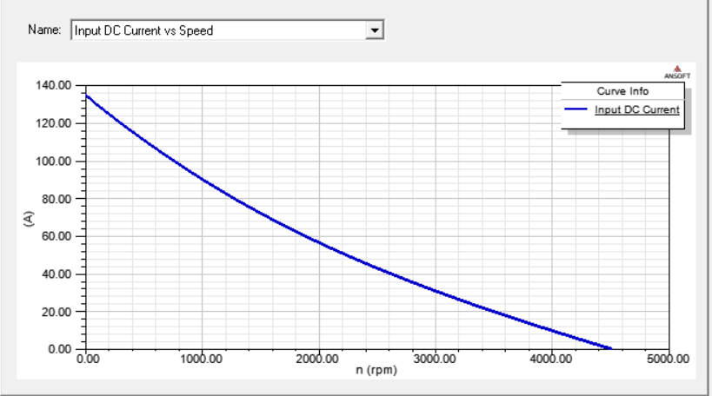

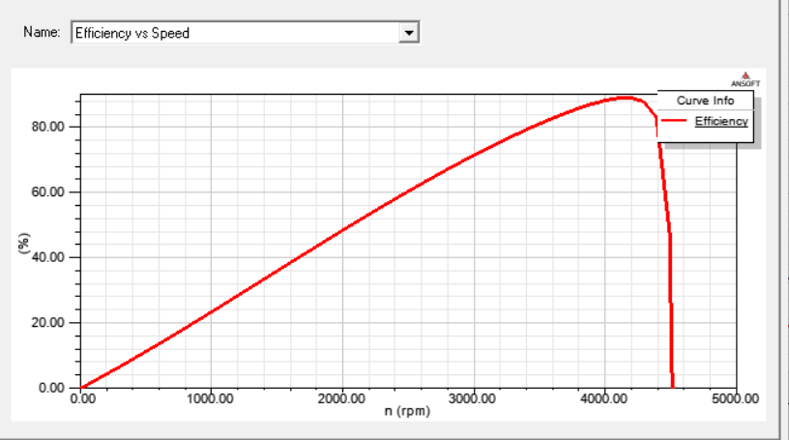

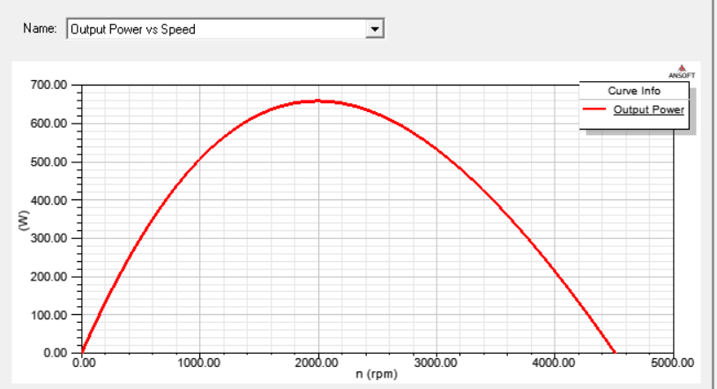

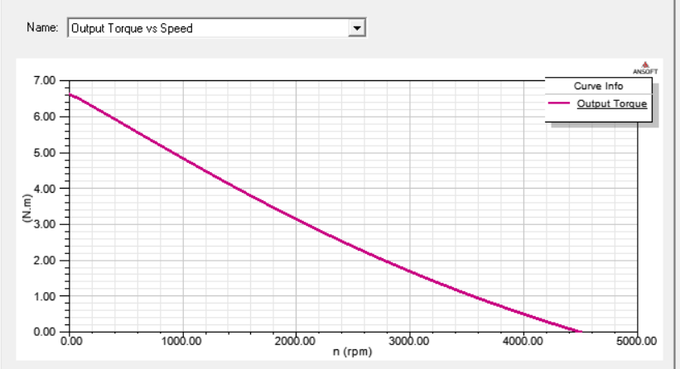





2-D Design of Motor:

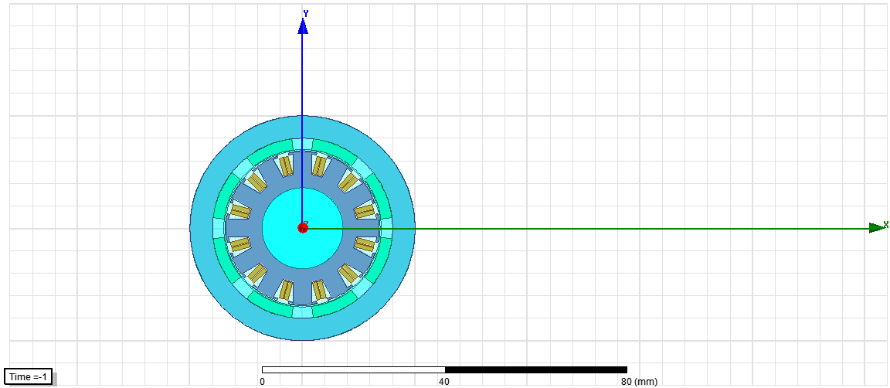

3-D Design of Motor:

